A New Discrete Self-tuning LQG Controller Applied to Geostationary Satellite System

Ali S. Zayed1

1 Department of Electrical and Electronic Engineering, Al Zawya University, Sabrata, Libya
Email: zayed_1964@yahoo.com

Abstract. The PID controller has been widely applied in control engineering, One of main reasons for its popularity is it provides the ability to remove the offset by using integral action. There it is desirable to include integral in other designs. In this paper, the algorithm of a new Self-tuning Linear Quadratic Gaussian (LQG) controller is presented. The new state space design is enhanced by an on-line Kalman filter. The on-line Kalman filter, which can be considered as a software sensor, is incorporated to ensure a robust performance when the states are difficult/expensive to sense by using conventional hardware sensors.
In addition, the methodology provides the user with the advantages of both PID and LQG controller. This can be achieved by introducing the integral action into LQG controller to ensure zero steady-state error. Moreover, the design retains the simplicity of adaptation used in other designs (i.e. transfer function techniques). This advantage enabling the controller to be combined with other controllers in multiple control framework.
Simulation study (using matlab software) was carried out to demonstrate the effectiveness of the new modified STLQG controller on the closed loop system performance. The controller was applied to geostationary satellite (GS) system simulated model and good results were achieved.

Keywords. Self-tuning Control, Discrete State-space LQG Design, On-Line Kalman filter, LQG Control and Satellite Attitude Control.

استحداث متحكم مبني على المربعات الخطية لجاوس واستخدامه للتحكم في موضع قمر صناعي

د. علي سعيد زايد

الملخص:
يعتبر المتحكم التناسبي التكاملي التفاضليPID) ) من أكثر الحاكمات المستخدمة بشكل واسع في هندسة التحكم. ومن أهم الأسباب لهذا التفوق هو مقدرة هذا المتحكم من خلال المؤثر التكاملي (Integral action) على إزالة التغير المفاجئ الذي قد يحدث من بعض المؤثرات الخارجية. ولهذا السبب أصبح من المستحسن دمج هذا المؤثر في بعض التصميمات الأخرى. وفي هذه الورقة البحثية تم استحداث متحكم جديد مبني على المربعات الخطية لجاوس (LQG). هذا التصميم تم تمثيله بطريقة فضاء الحالة (state-space) وتم تعزيزه بمرشح كالمن (Kalman Filter) المتأقلم مع التغيرات المحيطة. ويستخدم هذا المرشح الذي يمكن اعتباره كمجس غير مادي (Software Sensor) لضمان قوة الأداء ولحساب متغيرات الحالة (States) في حالة صعوبة تحسسها أو في حالة الاستغناء على بعض المصاريف التي قد تنتج من استخدام المجسات المادية. وبالإضافة إلى ذلك فإن المتحكم المقترح يتمتع بإمكانيات كل منPID) ) و(LQG) وذلك بإضافة المؤثر التكاملي إلى المتحكم (LQG) للتغلب على بعض التغيرات المفاجئة. ومن مميزات هذا التصميم أنه يتمتع بمزايا بعض التصميمات المبنية على دالة التحويل، مما يجعل من هذا المتحكم قابل لدمجه مع بعض الحاكمات الأخرى واحتوائه في نظام متعدد للحاكمات (Multiple Controllers Framework). تم إجراء محاكاة باستخدام برنامج ماتلاب للمتحكم المقترح لعرض أداء هذا المتحكم الذاتي التعديل و تم تجريبه على نموذج لقمر صناعي والنتائج المتحصل عليها كانت جيدة.

1 Introduction
Generally, linear quadratic Gaussian control represents one of the most prominent successes in control theory, largely due to its wide applications and its mathematical elegance in tractability [1, 2, 3]. However, Self-tuning controllers represent an important class of adaptive controllers, they are easy to implement and are applicable to complex processes with a wide variety of characteristics involving unknown parameters, the presence of time delay, time-varying process dynamics, and stochastic disturbances [4].

The approach used in STCs was first mentioned in the work of kalman [5] in 1958s. In his work a micro computer is designed to identify the parameters of a linear model process and subsequently the control law was calculated using minimum quadratic criteria. This problem was revived in the early 1970s by work of Peterka [6] and Astrom and Wittenmark [7] and others. The approach has been developed significantly since then. The first STCs were designed to minimize system output variance where some disadvantages were removed by the general minimization of output dispersion method developed by Clarke and Gawthrop [8].

Another approach to STCs design is to transform the estimated model into its equivalent state space form so that the design procedure is that applied for linear-quadratic- Gaussian (LQG) control. Such an LQG design was first presented in 1973s by Peterka and Astrom [9]. Their process model excluded colored noise processes. A microcomputer implementation of a LQG self-tuner is discussed by zhao-Ying and Astrom [10]. The LQG method demands a considerable computational effort and there are possibilities of minimizing the computing load, as proposed by Lam [11]. This can be handled by avoiding the numerical problems involved in iterating the Riccati equation. An extension to this work, the control design of Grimble [12], which is on transfer function approach, deals with implicit LQG self-tuners, which result in reduced computing load, as such schemes avoid the controller calculation stage involved in explicit LQG schemes. Grimble considers a robust LQG design of discrete systems using a dual criterion [13].

On the other hand, it well-established fact that the PID controllers are considered as dominant controllers. The main reason for this domination is due to the robustness of these controllers to control a wide range processes, the simplicity of their structures and also their ability to reject constant load disturbances.

The main contribution of this paper is to develop a new state-space self-tuning linear quadratic Gaussian framework. The new controller has the advantages of both PID and LQG controllers. Nevertheless, the controller methodology retains the simplicity of adaptation used in transfer function representation techniques. In order to assess the performance of the closed-loop system, the controller is applied to satellite model.

The paper is organized as follows: the satellite system model is presented in section 2, the algorithm of the new self-tuning linear quadratic Gaussian controller is discussed in section 3. In section 4, the simulation case study (controlling a geostationary satellite system) is carried out in order to demonstrate the effectiveness of the proposed controller. Finally, some concluding remarks are presented in section 5.

2 Satellite Model
Consider the problem of designing an attitude control system for a rigid satellite body in geostationary orbit. Geostationary satellite usually requires attitude control so that antennas, sensors, and solar panels are properly oriented. For example, antennas are usually pointed towards a perpendicular location on the earth while solar panels need to be oriented towards the sun for maximum power generation [14, 15].
Fig. 1. depicts this case where motion is allowed only about an axis perpendicular to the page.

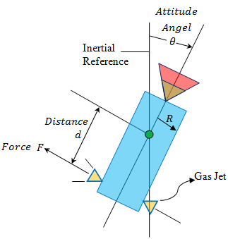
Fig. 1. rigid satellite body Schematic

The equations of motion of the satellite system are given by:
$J\ddot{θ}=M_{C}+M_{D}$ (1a)
$M_{C}=F×d$ (1b)
$J=\frac{1}{2}×MR^{2}$ (1c)
where $F$ is the force coming from the reaction jet, $d$ is the distance of the body from its mass center, $J$is the moment of inertia of the satellite about its mass centre, $M_{C}$is defined as the control torque applied by the thrusters which comes from the reaction jet, $M_{D}$ is the disturbance torque, $M$ is the mass of satellite, $R$ satellite radius and $θ \left(rad\right)$ is the angle of the satellite axis with respect to an “inertial” reference. Normalizing, we define:
$u\left(t\right)={M_{C}}/{J }$ (2)
And
$ξ^{'}\left(t\right)={M_{D} }/{J }$ (3)
The dynamic equation (1) becomes:
$\ddot{θ}\left(t\right)=\left(u\left(t\right)+ξ\left(t\right)\right)$ (4)
where $u\left(t\right)$ is the control input signal and $ξ\left(t\right)$ is the process noise.
Taking Laplace transform of equation (4), yields:
$θ\left(s\right)=\frac{1}{s^{2}}\left[U\left(s\right)+ξ\left(s\right)\right]$ (5)
The discrete model of the satellite system can be written as [14, 16]:
$θ\left(z\right)=\frac{T_{s}^{2}}{2} \frac{\left(z+1\right)}{{\left(z-1\right)}^{2}}\left[U\left(z\right)+ξ\left(z\right)\right]$ (6)
A discrete state-space of Single-Axis Geostationary Satellite attitude control model at $T_{s}=1sec$is:
$\left[\begin{matrix}X_{1}\left(t+1\right) \\ X_{2}\left(t+1\right)\end{matrix}\right]=\left[\begin{matrix}0 & 1 \\ -1 & 2\end{matrix}\right]\left[\begin{matrix}X_{1}\left(t\right) \\ X_{2}\left(t\right)\end{matrix}\right]+\left[\begin{matrix}0.5 \\ 1.5\end{matrix}\right]u\left(t\right)+\left[\begin{matrix}0.5 \\ 1.5\end{matrix}\right]ξ\left(t\right)$ (7a)
$y\left(t\right)=\left[\begin{matrix}1 & 0\end{matrix}\right]\left[\begin{matrix}X_{1}\left(t\right) \\ X_{2}\left(t\right)\end{matrix}\right]+v'\left(t\right)$ (7b)
In this model, the state $X_{1}\left(t\right)$ is the position state (rad) of satellite, and the state $X_{2}\left(t\right)$ is the velocity state of satellite (rad/sec). However, in this work the proposed controller is used to control the position of one axis of the satellite model (i.e. Pitch, Yaw or Role).

3 The New LQG Controller Algorithm
This control design is an extension to the previous works of [14, 16]. Fig.2. shows the self-tuning linear quadratic Gaussian with reference signal $r\left(t\right)$ and integral control block.
In Fig. 2., the estimated dc gain $N\left(\hat{θ}\right)$ is introduced on-line into the design to ensure that, in the steady-state, the system output signal $y\left(t\right)$ is equal to the reference signal $r\left(t\right)$. The vector $\hat{θ}$ represents estimated satellite plant parameters.

where:$\hat{θ}={\left[-{\hat{a}}_{1}-{\hat{a}}_{2}⋯-{ \hat{a}}_{n_{a}}{ \hat{b}}_{0}{ \hat{b}}_{1 }{\hat{b}}_{2}⋯{\hat{b}}_{n_{b}} { \hat{c}}_{0}{ \hat{c}}_{1 }{\hat{c}}_{2}⋯{\hat{c}}_{n_{c}}\right]}^{T}$

$v'\left(t\right)$
$\frac{1}{A}$
$v\left(t\right)$
Adaptive Kalman filter
$+$
${\hat{X}}_{c}\left(t,\hat{θ}\right)$
$y'\left(t\right)$
$+$
$r\left(t\right)$
$N\left(\hat{θ}\right)$
$\left(\hat{θ}\right)$
$-K_{c}\left(\hat{θ}\right)$
$+$
$+$
$e\left(t\right)$
$-$
Integrator

$\frac{-k_{I}z}{z-1}$
$X_{I}\left(t\right)$
$+$
$u\left(t,\hat{θ}\right)$
Plant

$A, B$
$y\left(t\right)$
$X\left(t\right)$
E
$C$
$ξ(t)$
Recursive Identification

Fig. 2. Self-Tuning Linear Quadratic Gaussian controller with integral action

A discrete state-space model of any system can be presented by a discrete matrix-vector equation as follows [16]:
$X\left(t+1\right)=AX\left(t\right)+Bu\left(t\right)+Cξ^{'}\left(t\right)$
$$y\left(t\right)=EX\left(t\right)+b_{0}u\left(t\right)+ξ^{'}\left(t\right)+v'\left(t\right)$$
where $X\left(t\right)$ and $X\left(t+1\right)$is the $n×1$ state vectors, $u\left(t\right)$ is the control input signal, $y\left(t\right)$ is the system output signal,$ξ^{'}\left(t\right)$defined as the process noise and $v'\left(t\right)$ is Measurement Noise. $A$ is the $n×n$system dynamic matrix$, B$is the $n×1$ input matrix, $E$is the $1×n$ output matrix,$C$ is the$n×1$ noise matrix, $n$ is the order of the system and $\left(t\right)$ equals to $kT_{s}, k$ denotes the sampling instants or $k=1,2,3,⋯, T_{s}$ means the sampling time. The values of $A, B$, $E$ and $C$ can easily be obtained from CARMA model [14, 16]. This property enables the user to combine both state-space and transfer function designs in a multiple framework.
The values of both control input signal $u\left(t\right)$ and system output signal $y\left(t\right)$ are read every sampling instant in order to estimate satellite plant parameters$\hat{θ}$.
In Fig. 2., the adaptive gain N ($\hat{θ})$ ,which can be obtained from the Recursive Least Squares estimator, is introduced in order to ensure that the output tracks the reference signal r ($t$) ( i.e. y ($t$) = r($t$) at steady state region).
In order to design STLQG controller, the estimated plant parameters $\hat{θ}$, which are calculated by RLS, are used to formulate the new identified state-space model as:
$x_{c}\left(t+1,\hat{θ}\right)=A_{c}\left(\hat{θ}\right)x_{c}\left(t,\hat{θ}\right)+B_{c}\left(\hat{θ}\right)u\left(t,\hat{θ}\right)+C_{c}\left(\hat{θ}\right)ξ\left(t\right)$ (8a)
$y_{c}\left(t,\hat{θ}\right)=E_{c}\left(\hat{θ}\right)x_{c}\left(t,\hat{θ}\right)+B_{c}\left(\hat{θ}\right)u\left(t,\hat{θ}\right)+ξ\left(t\right)+v'\left(t\right)$ (8b)

where $A_{c}\left(\hat{θ}\right)=\left[\begin{matrix}0 & 1 & 0 & ⋯ & 0 \\ 0 & 0 & 1 & … & 0 \\ ⋮ & ⋮ & ⋮ & … & ⋮ \\ 0 & 0 & 0 & ⋯ & 1 \\ -{\hat{a}}_{na} & -{\hat{a}}_{na-1} & -{\hat{a}}_{na-2} & … & -{\hat{a}}_{1}\end{matrix}\right]$ , $B_{c}\left(\hat{θ}\right)=\left[\begin{matrix}0 \\ 0 \\ 0 \\ ⋮ \\ 1\end{matrix}\right]$
$C_{c}\left(\hat{θ}\right)=\left[{\hat{b}}_{nb} {\hat{b}}_{nb-1}……{\hat{b}}_{1}\right]$, $E_{c}\left(\hat{θ}\right)=\left[{\hat{C}}_{nc} {\hat{C}}_{nc-1}……{\hat{C}}_{1}\right] and v'\left(t\right)$ is Measurement Noise.
The next step is to choose the user-defined gain R and the user pre-specified matrix Q to be positive definite to insure that the controller is converges to stability conditions.
At this stage, the adaptive Riccati equation expressed by the following equation:
$P\left(\hat{θ}\right)=Q+A_{c}^{T}\left(\hat{θ}\right)\left(P\left(\hat{θ}\right)-P\left(\hat{θ}\right)×B_{c}\left(\hat{θ}\right)×\left(R+B_{c}^{T}\left(\hat{θ}\right)×P\left(\hat{θ}\right)×B_{c}^{T}\left(\hat{θ}\right)\right)×B_{c}^{T}\left(\hat{θ}\right)× P\left(\hat{θ}\right)\right)$ (9)
The adaptive p matrix can be used to evaluate the needed adaptive gain matrix K$(\hat{θ})$ as follows:
$K_{c}\left(\hat{θ}\right)={(R+B_{c}^{T}\left(\hat{θ}\right)P\left(\hat{θ}\right)B_{c}\left(\hat{θ}\right))}^{-1}B_{c}^{T}\left(\hat{θ}\right)P\left(\hat{θ}\right)A_{c}\left(\hat{θ}\right)$(10)
The gain N$(\hat{θ})$ can be calculated as follows:
${(N(\hat{θ}))}^{-1}=-E_{c}\left(\hat{θ}\right){\left(A_{c}\left(\hat{θ}\right)-B_{c}\left(\hat{θ}\right)K_{c}\left(\hat{θ}\right)-I\right)}^{-1}B_{c}\left(\hat{θ}\right)$ (11)
As can be seen from above Figure, the integral block is added to the self-tuning linear quadratic Gaussian controller in order to enable the controller to eliminate both external disturbance and steady-state error.
The integral state${ X}_{I}\left(t\right)$ represents the integral of the error$e\left(t\right)=y\left(t\right)-r\left(t\right)$.
The discrete integral is simply a summation of all past values of$e\left(t\right)$, which results in the difference equation:
${ X}_{I}\left(t+1\right)={ X}_{I}\left(t\right)+e\left(t\right)={ X}_{I}\left(t\right)+EX\left(t\right)-r\left(t\right)$ (12)
Figure (2) shows that the control-law can be written as:
$u\left(t,\hat{θ}\right)=N\left(\hat{θ}\right)r\left(t\right)-\left[\begin{matrix}K_{I} & K_{c}\left(\hat{θ}\right)\end{matrix}\right]\left[\begin{matrix}X_{I}\left(t\right) \\ {\hat{X}}_{c}\left(t,\hat{θ}\right)\end{matrix}\right]$ (13)
Where:
$u\left(t,\hat{θ}\right)$: optimal adaptive control signal.
N$(\hat{θ})$: adaptive gain.
$r\left(t\right)$: reference signal.
$K_{c}(\hat{θ})$: adaptive gains matrix.
${\hat{X}}_{c}\left(t,\hat{θ}\right)$: adaptive estimated system states.
$X_{I}\left(t\right)$: the integral state.
$K_{I}$: integral gain.
$P\left(\hat{θ}\right)$ : adaptive positive definite Lapanove matrix.
The adaptive time-varying Kalman filter is a generalization of the steady-state filter for time-varying systems or LTI systems with non stationary noise covariance. Given the plant state and measurement equations as:
$X\left(t+1\right)=AX\left(t\right)+Bu\left(t\right)+Cξ\left(t\right)$
$y\left(t\right)=EX\left(t\right)+β_{0}u\left(t\right)+ξ\left(t\right)+v'\left(t\right)$
where, $X\left(t\right)$ and $X\left(t+1\right) are$ the $n×1$ state vectors, $u\left(t\right)$ is the control input signal, $y\left(t\right)$ is the system output signal,$ξ\left(t\right)$defined as process noise, $v\left(t\right)$is the measurement noise$; A$is the $n×n$system matrix$, B$is the $n×1$ input matrix, $E$is the $1×n$ out-put matrix;$C$is the$n×1$ disturbing matrix, $n$ is the order of the system and $\left(t\right)$ equals to $k^{'}T_{s}, k^{'}$denotes the sampling instants or $k^{'}=1,2,3,⋯, T_{s}$ means the sampling time.
The adaptive time-varying Kalman filter is given by the following recursions:
Firstly, the measurement update period in which the estimation of the states, evaluating the covariance matrixes (P1($\hat{θ}$) and M($\hat{θ}$)) are performed at current time depending on the values of (estimated states, P1($\hat{θ}$) and M($\hat{θ}$)) in previous time. The measurement update equations can be arranged as follows:
$M(\hat{θ})=P1(\hat{θ})E_{C}^{T}(\hat{θ})/(E_{c}(\hat{θ})P1(\hat{θ})E_{C}^{T}(\hat{θ})+ R)$ (14a)
${\hat{X}}_{c}\left(t,\hat{θ}\right)={\hat{X}}_{c}\left(t,\hat{θ}\right)+M\left(\hat{θ}\right)\left(y\left(t\right)-E_{c}\left(\hat{θ}\right){\hat{X}}_{c}\left(t,\hat{θ}\right)\right)$ (14b)
$P1(\hat{θ})=P1(\hat{θ})-M(\hat{θ})E_{c}(\hat{θ})*P1(\hat{θ})$(14c)

where M($\hat{θ}$) is the adaptive covariance matrix, P1($\hat{θ}$) is the adaptive error covariance matrix that is set initially as: $B_{c}\left(\hat{θ}\right)$ $Q B_{c}^{T}\left(\hat{θ}\right),$ $Q$ is the scalar process noise covariance and $R$ is the scalar sensor noise covariance, $B_{C}(\hat{θ})$ is the adaptive input matrix of the system, $E_{c}(\hat{θ})$ is the adaptive output matrix of the system,${\hat{ X}}_{c}\left(t,\hat{θ}\right)$ is the adaptive state vector and $y\left(t\right)$ is the system output signal.
Secondly, the time update period in which the next estimated states and P1 are calculated depending on the values of (estimated states, P1($\hat{θ}$) and M($\hat{θ}$)) at current time. The time update equations are presented as follows:
${\hat{X}}_{c}\left(t,\hat{θ}\right)=A_{c}\left(\hat{θ}\right){\hat{X}}_{c}\left(t,\hat{θ}\right)+B_{C}\left(t\right)u\left(t,\hat{θ}\right)$(15)
$P1(\hat{θ})=A_{c}(\hat{θ})P1(\hat{θ})A_{c}^{T}(\hat{θ})+B_{c}(\hat{θ})Q1* B_{c}^{T}(\hat{θ})$ (16)
Where:
$A_{c}(\hat{θ}):$ is the adaptive system matrix.
$u\left(t,\hat{θ}\right):$ is the adaptive optimal control signal.
The function of using the Adaptive Kalman Filter in this control design is to estimate adaptive system states with filtration to the output signal from the noise that introduced by plant or by measuring sensor equipment.
The algorithm of self–Tuning Linear Quadratic Gaussian controller with integral action can be summarized as follows:
Step 1: select $Q$ as a positive definite matrix, $K_{I}$ and $R$ as an integer values.
Step 2: Read the new values of $y\left(t\right)$ and $u\left(t\right)$.
Step 3: Estimate the process parameters $\hat{θ}$ using RLS estimator or RELS estimator and formulate a new identified state – space model of the plant $\left\{A_{c}\left(\hat{θ}\right),B_{c}\left(\hat{θ}\right), E_{c}\left(\hat{θ}\right),C_{c}(\hat{θ})\right\}$ using equations (8a) and (8b).
Step 4: Calculate Adaptive $P\left(\hat{θ}\right)$matrix using equation (9).
Step 5: Calculate $K_{c}(\hat{θ})$ Adaptive gains matrix using equation (10).
Step 6: choose the integral gain${ K}_{I}$.
Step 7: Calculate the integral state $X_{I}\left(t\right)$ using equation (12).
Step 8: Compute $N(\hat{θ})$ using equation (11).
Step 9: Apply the adaptive optimal control signal using equation (13).
Step 10: Estimate Adaptive system states${\hat{X}}_{c}(t,\hat{θ})$, using equation (15).
Step 2 to 10 are repeated every sampling instant.

4.0 Simulation results
The objective of this section is to assess the performance and the robustness of the closed loop system using the new self-tuning LQG controller. The satellite case study is used to show the ability of the proposed controller, which is enhanced by an adaptive Kalman filter, to track the reference signal in the presence of measured load disturbance and set-point change. The simulation experiment was performed using the geostationary satellite system described by discrete state-space dynamic equation given by equations (7a) and (7b). The simulation was performed using (RELS) estimator over 500 samples (approximately 8 minutes) to track a reference signal representing the desired set point changes from 1 to -1 and from -1 to 1 every 50 sampling instants.
The controller parameters $Q,$ $K_{I}$ and $R$ were selected as follows:
$K_{I}=25$, $Q=\left[\begin{matrix}1 & 0 \\ 0 & 0\end{matrix}\right]$ and $R=10.$
In order to investigate the influence of the measured disturbance on the closed loop system, an artificial constant load disturbance (step signal) of value 1.4 was added to the output at the 20th sampling instant . The output and optimal control input signals are shown in figures (3a) and (3b), respectively.

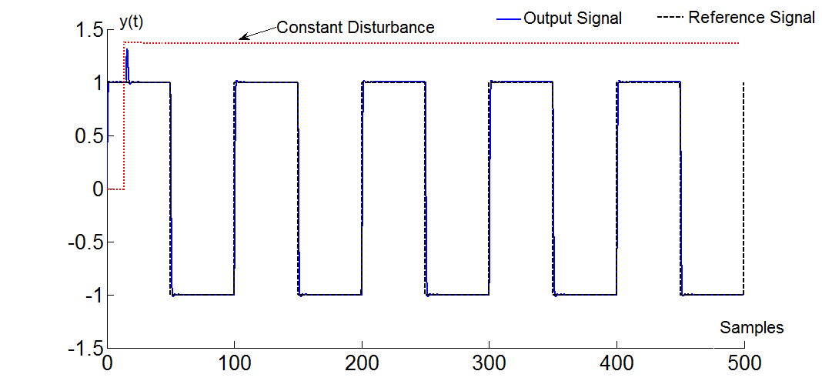
Fig. 3a. the Output of (GS) System
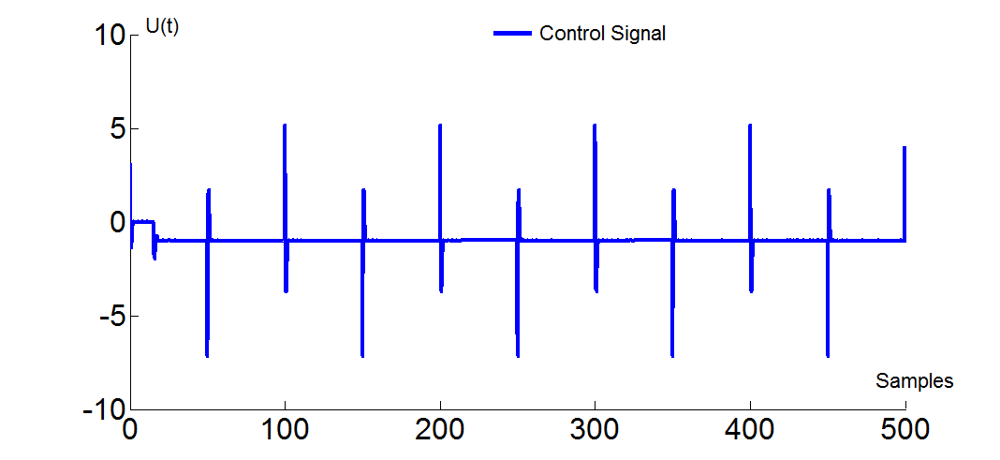
Fig. 3b. the optimal Control Input of (GS). System

It can be seen from Fig.3a. and Fig. 3b. that the controller has the ability to track set-point change and successfully regulate the measured load disturbance to zero.

5.0 Conclusions
In this paper, a new modified self-tuning LQG controller based on discrete state-space technique has been described. The presence of the on-line Kalman filter estimator, which can be considered as a software sensor, enables the designer to deal with systems in which the states are difficult or expansive to sense. The design was successfully tested on satellite plant model. The results presented here indicate that the controller tracks set point changes and at steady-state the controller has the ability to reject constant load disturbances to zero. The design, which is based on state-space representation, retains the simplicity of adaptation mechanism shown on transfer function designs. This advantage allows the controller to be incorporated easily with other transfer function designs in a multiple framework. Moreover, the main advantage of the proposed work is that the design which based on new state-space technique can provide more flexibility to deal with non-linear systems.
However, in this paper only single-input single-output case study is considered and the pre-specified control parameters $Q,$ $K_{I}$ and $R$ are selected using a trial and error method. A further research may be performed to investigate the possibility of using soft-computing methods such as genetic algorithms to obtain the optimal values of these parameters and to extend this work to incorporate multi-input multi-output systems.

Acknowledgements
The author is indebted to Professor Amir Hussain, Personal Chair and Head of Cognitive Signal Image Processing and Control Systems Research (COSIPRA) Laboratory, University of Stirling, Stirling (UK) for highly stimulating discussions and his insightful comments and suggestions. The authors are also grateful to anonymous reviewers for their constructive comments.

References
[1]. B. D. O. Anderson , J. B. Moor, 1990, ‘Optimal Control, Linear Quadratic Methods’, Englewood Cliffs, NJ: Prentic-hall.
[2]. Li Duan, Fucai Qian, 2004,‘Closed-Loop Optimal Control Low for Discrete-Time LQG Problems with a Mean-Variance Objective’, 43rd IEEE Conference on Decision, December 14-17, 2004, Atlantis, Paradise Island, Bahamas.
[3]. A. J. Shaiju, I. R. Petersen and M. R. James , 2007, ‘Guaranteed Cost LQG Control of Uncertain Linear Stochastic Quantum System ’, American Control Conference, July 11-13, 2007, New York City , USA.
[4]. V. V. Chalam, 1987, ’Adaptive Control System Techniques and Application‘, Marcel Dekker.
[5]. R. E. Kalman, 1958, ’Design of a self optimizing control system, ‘ Trans. ASME,vol. 80.
[6]. V. Peterka,1970 “Adaptive digital regulation of noisy systems,” in Preprints of the 2nd IFAC Symposium on Identification and Process Parameter Estimation, Prague: ´UTIA ˇCSAV.
[7]. K.J.Astrom and B. Wittenmark, 1973, “On self-tuning regulators,” Automatica,vol. 9, pp. 185–199.
[8]. D. W. Clarke and P. J. Gawthrop, 1975, “Self-tuning controller,” Proc. IEE, vol. 122. pp. 929–934,
[9]. V. Peterka, Astrom, K. J., 1973, ‘control of multivariable system with unknown but constant parameters’ Proc. 3rd IFAC symp, on Identification and process parameter Estimation , The Hague.
[10]. Z. Zhao-Ying, Astrom, K. J., 1981, ‘A microcomputer implementation of LQG self-tuner’, Report No. TFRT- 7226, Dept. of Auto. Contr., Lund Inst. Of Tech., Lund. Sweden.
[11]. K. P. Lam, 1980, ‘implicit and explicit self-tuning controllers’, Doctoral Thesis, Oxford University.12]. M. J. Gimple, 1983, ‘self-tuners based on LQG theory’ Pergamon Press, Oxford.
[13]. M. Haraguchi, H. Y. Hu, 2008, ’Using a new discretization approach to design a delayed LQG controller‘ Science Direct, Journal of sound and vibration.
[14]. Ahmed M. Elnajeh, 2010,’ Self-tuning Observer Pole-pacement Based On State-space Technique‘, MSc., The Department of Computer and Electrical Engineering, Academy of Graduate Studies, Tripoli, Libya.
[15]. Gene F. Franklin, J. David Powell, Michael L. Workman, 1998, ‘Digital Control of Dynamic Systems’, 3nd ed., Addison-Wesley.
[16] Ali S Zayed and Ahmed M. Elnajeh, 2011,’ A New Self-tuning Observer Pole-pacement Controller Using State-Space Technique‘, Twelfth International Conference on Sciences and Techniques of Automatic Control and Computer Engineering (STA2011‘), Paper No. 84, Sousse, Tunisia, 18-20 Dec., 2011.

