THE INFLUENCE OF THERMAL CYCLING ON THE CORROSION AND HARDNESS OF LOW CARBON STEEL

Mr. Ashraf M. Elaieb¹ , Dr. Farag M. Shuaeib¹, Dr Ramadan O. Saied²
and Mr. Mohamed G. Almalki¹

¹Mechanical Engineering Department, Faculty of Engineering, Benghazi University, Benghazi, Libya
²Mechanical & Industrial Engineering Department, Faculty of Engineering, Tripoli University, Tripoli, Libya
E-mail: drfmshuaeib@yahoo.com.
Tel: 00218-926225683
الملخص
يتناول البحث الحالي دراسة تاثير الدورات الحرارية المتكررة على الصلادة و مقاومة التآكل للصلب منخفض الكربون عند درجات حرارة مختلفة ( 300، 400 ، 500 و 600 د. م) وتتضمن كل درجة عدد من الدورات ( 10 ، 20، 30 و 40 دورة). هذا النوعِ مِنْ الصلب رخيصُ الثمن نسبيا و يمتاز بسهولة تشكيله و لحامه و لذلك فهو مستعمل على نطاق واسع في المنشآت الصناعية مثل المبادلات الحراريةِ وانابيب البخاروالغلايات وأبراجَ التبريد ، وأجهزةَ نقلِ الحرارةِ المماثلةِ. أثناء عمليةِ التشغيل الطبيعيةِ او في الحالات غير الإعتيادية قد تخضَعُ هذه الأجهزةِ إلى دورات حراريةِ (تسخين وتَبريد لاحق) والتي عادة ما تكون تحت درجةِ حرارة التحول الطوري للصلب (≈ 723 د.م). في السابق كان العمل على هذا الموضوع يتم بدراسة تأثير المعالاجات الحرارية القياسية و التي ترفع فيها درجات الحرارة اعلى من درجة التحول الطوري (اي يكون التركيب اوستنايت) و بإستعمال الطريقة الكلاسيكية للدراسة و ذلك بتَغيير عامل واحد كل مرة وتثبيت العوامل الباقية. تتطـلب هذه الطريقة الكثير من العينات والعملِ التجريبيِ الذي يعد عالي التكلفة علاوة على استهلاك وقت أطول إضافة إلى أن الطريقة الكلاسيكية لَيست قادرة على اكتشاف التأثير المشترك الذي يحدث عند تغيير أكثر من عامل واحد في نفس الوقت. العوائق السابقة أمكن معالَجتها باستعمال علم ومنهجية تصميمِ التجارب بالطرق الإحصائية. وفقاً لذلك فقد تم استخدام اسلوب تصميم التجارب و تم استخدام احد البرامج الإحصائية المتميزة في تصميم التجارب ومن ثم القيام بالتجارب المطلوبة وفق التصميم المعد و تحليل النتائج و كذلك الحصول على نماذج رياضية للتنبؤا بسلوك هذا النوع من الحديد بتأثير الدورات الحرارية. بينت النتائج ان الصلادة تزداد بزيادة درجة حرارة الدورات الحرارية و عدد الدورات و تصل الى اقصى قيمة عند درجة حرارة 500 م تقريبا ثم تنخفض. اما لاختبارات التآكل فبينت النتائج ان التآكل يقل كلما زادت درجة حرارة الدورات الحرارية وعدد الدورات الى ان يصل الى اقل قيمة عند درجة حرارة 500 م و يزداد اعلى من 500 م . الإجهادات الداخلية المتبقية ، و التغير البلوري، و الأكسدة هي العوامل المؤثرة في هذه التغيرات كما هو موضح في الورقة.

ABSTRACT
This work studies the influence of thermal cycling on the corrosion and hardness behavior for low carbon steel material at temperatures of 300 400, 500, and 600 ºC and number of cycles of 10, 20, 30 and 40. This type of steel is cheap and extensively used in industry for structures such as heat exchangers, condensers pipes, boiler tubes, cooling tower pipes and similar heat transfer equipments. During the normal operation of these equipments, this material is subjected to thermal cycles which are usually below the first phase transformation temperature for steel (~723ºC). Therefore, this paper investigates the effects of these thermal cycles on the material corrosion and hardness behavior. Previous work was either considering standard heat treatment methods or using the classical method of changing one parameter at a time. In this work the temperature range selected is below the 723 ºC and the Design of Experiment (DOE) was implemented to tackle previous research shortcomings. Accordingly, factorial and RSM designs of experiment were created; specimens were prepared and thermally cycled according to the design of experiment set up. Performance tests (Hardness, and corrosion) were performed. The results showed that increasing the thermal cycling temperature; generally increased the hardness until about 500ºC, and then it is followed by a decrease in the hardness. The corrosion rate increased for a small region then comes to a minimum at about 500 ºC then it rises again. Residual stresses, microstructure changes and oxidation are responsible for these effects as detailed in the paper.
Key words: Thermal cycling, corrosion, residual stresses, hardness, low carbon steel, tempering.

INTRODUCTION
Carbon steel is by far the most widely used kind of steel. The properties of carbon steel depend primarily on the amount of carbon it contains. Most carbon steel has a carbon content of less than 1%. Low carbon steel is easily available and cheap having all material properties that are acceptable for many applications , including structural beams, car parts and bodies, kitchen appliances, cans, pipe line, railways, tractors and agriculture implement, petrochemical and engineering industries [1 - 5]. In many industrial applications such as boilers, superheaters, heat exchangers, and thermal reactors, the carbon steel parts may be subjected to heating then cooling many times throughout the operation; these heating and cooling is called thermal cycling. When a part is rapidly cooled in a solution such as water that produces a high heat transfer, the temperature differences create high thermal stresses which often cause distortions in the microstructure and also works on the creating of stresses[6]. These internal reasons resulting from the operations of the heating and cooling and changes in its dimensions (expansion and contraction), results on an increase in hardness, and from nature of the metal if it is increased in hardness, would be more resistant to wear (particularly erosion), but these stresses and these distortions may make the metal more susceptible to corrosion on the contrary than it is in the hardness and wear resistance. This may affect the mechanical and tribological properties of the metal. Jokhio et al. [7] conducted various types of heat treatment on carbon steel and found that water quenching of low carbon steel specimen has the highest tensile strength and hardness. However this treatment gives the lowest ductility and toughness compared to other treatments. They concluded that quenching is recommended when strength and hardness are the prime factor in design. The microstructure of steel consists of matrix of ferrite and pearlite. The grain fines of pearlite increases by increasing the rate of cooling. However, they have not considered the temperatures below the first transformation temperature (A₁). T. Foley and A. Levy [8] conducted erosion study on low carbon steel and found that the ductility of the steels (and consequently hardness) had a significant effect on their erosion resistance which increased with decreasing ductility. This suggests that the hardness can be utilized as a preliminary erosion resistance performance parameter.

MATERIALS AND METHODS
Table 1 shows the chemical composition of the low carbon steel used in this investigation. The material which has ASTM code A576 (Grade 1018) has a very close chemical and mechanical characteristics to the ASTM A214 heat exchanger and condenser tubes material. Specimens were cut from a rod in a form of a cylindrical shape with 20 mm in diameter and 10 mm in length as shown in Fig. 1 .The specimens, in the as-received condition, were annealed to remove any stresses which might be introduced during manufacturing and cutting. The treated test specimens contact surface was finished by grinding and polishing with 80 and 800 grit number emery paper to obtain approximately the same roughness.

Table 1: ASTM-A576, Grade1018 Chemical composition
Element | C | Mn | ph | S
% | 0.14 - 0.21 | 0.25 -0.4 | 0.4 | 0.05

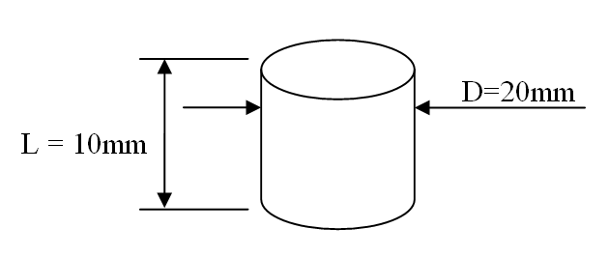 | 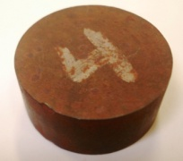
Specimen dimensions | Physical shape
Fig. 1: test specimen

DESIGN OF THE EXPERIMENTS
In this work a design of experiment which uses the Response Surface Methodology (RSM) coupled with a factorial design to plan the experimental work was implemented. The main factorial design would cover a wider range of the process parameters and would provide a simple method of results presentation, while the response surface would cover a narrower range “that is believed to be more critical " and would allow for a comprehensive analysis, and developing an empirical model. After the design factors and their levels were set, based on literature values and also after performing few trials, the design of experiment matrixes were created, using MINITAB software. Subsequently, the thermal cycling processes were carried out according to the designed experiment matrixes listed in Tables 2 and 3. Thereafter hardness, and corrosion performance tests were performed and results were then introduced into the designed matrixes.

Description of the Thermal Cycling Process
This process involved the following steps and shown schematically in Fig. 2. Two specimens for each setting (Exp. No) were heated to the required temperature according to Tables 2 and 3. Then they were allowed to homogenize at that temperature for 1 hour. After homogenizing the specimens were taken out of the furnace and immediately cooled in water bath (between 25 to 35 ºC). This constitute one cycle at the experiment cycling temperature. For each experiment No., the previous steps were repeated to the required cycles. After all experiments were completed, specimens were then taken out for hardness, and corrosion testing. The hardness values were determined on Rockwell B hardness tester (HRB- kg/mm²). The corrosion test was based on subjecting the specimens to the environmental (Industrial atmosphere) corrosion for a period of 3 months.
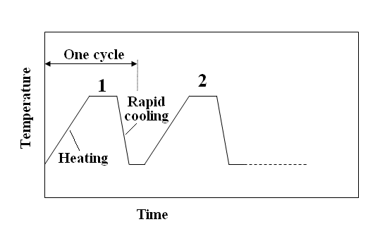
Fig. 2: The thermal cycling process

Table 2: The factorial design matrix
Exp. No | Number of cycles | Cycling temp. ºC | Hardness  (HRB) | Corrosion  Wt loss ( g)
1 | 40 | 400 | 83.1 | 0.449
2 | 10 | 400 | 82.6 | 0.578
3 | 30 | 600 | 81 | 0.58
4 | 40 | 300 | 81.6 | 0.379
5 | 10 | 600 | 84.6 | 0.876
6 | 20 | 400 | 81.5 | 0.498
7 | 10 | 300 | 78.7 | 0.466
8 | 10 | 500 | 83.7 | 0.438
9 | 30 | 300 | 80.7 | 0.509
10 | 20 | 300 | 80.4 | 0.524
11 | 40 | 600 | 80.5 | 0.982
12 | 20 | 600 | 83.3 | 0.653
13 | 30 | 500 | 88.4 | 0.339
14 | 30 | 400 | 82.6 | 0.513
15 | 40 | 500 | 91 | 0.361
16 | 20 | 500 | 85.4 | 0.373

Table 3: The RSM design matrix
Exp.  No | Number  of cycles | Cycling  Temp. ºC | Hardness (HRB) | Corrosion  Wt loss ( g)
1 | 30 | 600 | 81 | 0.58
2 | 20 | 400 | 81.5 | 0.498
3 | 20 | 500 | 85.4 | 0.373
4 | 40 | 400 | 83.1 | 0.449
5 | 40 | 500 | 91 | 0.361
6 | 40 | 600 | 80.5 | 0.982
7 | 30 | 400 | 82.6 | 0.513
8 | 30 | 500 | 88.4 | 0.339
9 | 20 | 600 | 83.3 | 0.653

RESULTS AND ANALYSIS
After all thermal cycling processes were carried out, hardness and corrosion performance tests were performed and results were introduced into the previously designed matrixes (Tables 2 and 3), the design matrixes were then analyzed using MINTAB software. Two types of analysis are presented, the first one is the factorial design analysis (Table 2), and the second is the response surface method (RSM) analysis (Table 3).

Factorial Results Analysis
Hardness results: The form of the output generated for the factorial design analysis is shown in Fig. 3-a&b. As shown, the factorial analysis shows that the maximum hardness is obtained at around the 500 ºC and the hardness in general increased by increasing the number of cycles. The interaction between the hardness results is not clear from the plot in Fig. 3-b, but it does not confirm that there is no interaction as there are some stages where the lines are not parallel. It is to be noted that the factorial design uses a straight lines to join the results between levels. Therefore, the RSM analysis was added to take over this limitation.
Corrosion results: The form of the output generated for the factorial design analysis is shown in Fig. 4- a&b. The factorial analysis shows that the minimum corrosion rate is obtained around the 500 ºC and the corrosion rate in general decreased by increasing the number of cycles, to a minimum then it increases again. Once again, the interaction between the corrosion results is not clear. But it does show that there is some sort of interaction at both the beginning and the end of the results. In summary, it can be concluded that there is an agreement of peak value existence at 500 ºC for both the hardness and the corrosion measurements. This is very interesting finding. Also it appears that, increasing the number of cycles tends to increase the hardness and decrease the corrosion which is more valid up to the 500 ºC cycling temperature.

Response Surface Method (RSM) Analysis
After the RSM matrix is completed by introducing the results as shown in Table 3, the design matrix was analyzed using RSM routines in MINITAB software. The full quadratic model was selected to analysis the response surfaces. The output results were generated in the form of contour plots and three dimensional response surface plots; statistical models were also produced.
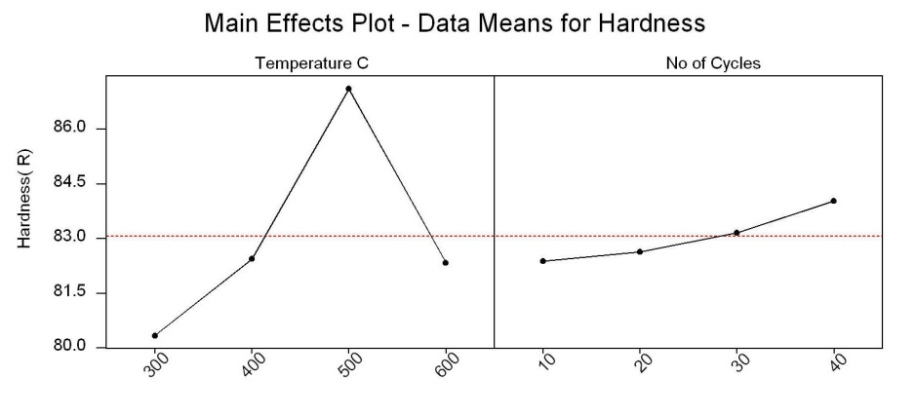
(a)
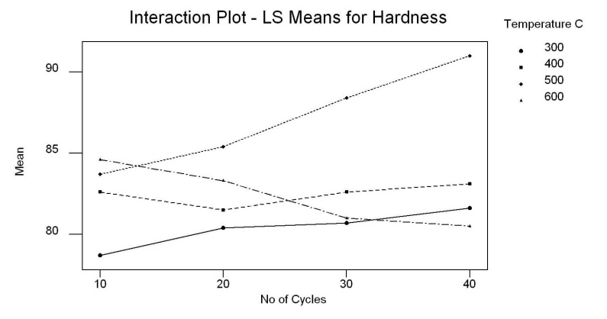
(b)
Fig. 3: The main (a) and the interaction (b) effect for the hardness
by factorial design analysis.
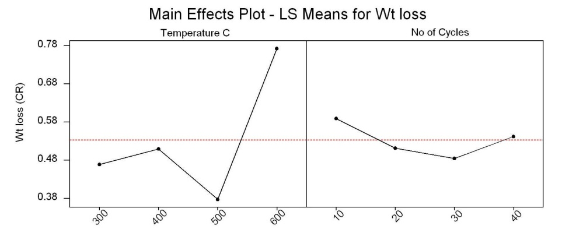
(a)
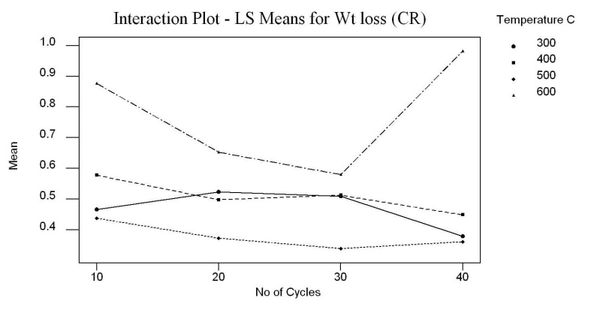
(b)
Fig. 4: The main (a) and the interaction (b) effect for the corrosion rate (CR)
by factorial design analysis
Hardness RSM Analysis: The hardness results were analyzed and the interactions of thermal cycling parameters were identified. Regarding the statistical model (see appendix-A), the statistical analysis for the full quadratic model for hardness results gives coefficients of determination of R² and R²-Adj equal to 86.7% and 65 % respectively, which shows that the performed hardness regression is good.
Therefore, the verified model of hardness is as follows:

HRB = - 83.99 + 0.5433 C + 0.6557 T+ 0.00134 C²
-0.00063T² - 0.00110 CT (1)
Where, HRB is the hardness, C is number of cycles, T is cycling temperature (ºC).

Hardness parametric study: The effects of thermal cycling processing parameters on hardness are presented in Figs. 5 and 6 as 3D surface plot and contour plot obtained using MINITAB regression model of Eq.(1). As shown , the effect of the cycling temperature is more significant than the number of cycles. Regarding the number of cycles, the increase is almost linear within the selected range. However, the effect of the cycling temperature is increasing the hardness in a non-linear curve until a peak at 500 ºC, and then it is decreases again. The overall response looks like a tilted saddle. These findings are confirmed by the contour plot shown in Fig. 6, which shows that the effect of the number of cycles can reasonably be represented by horizontal lines. The effect of the cycling temperature is very clear with a region of maximum hardness near 500 ºC. This temperature is the start of the grain re-crystallization where after this temperature stress reliving would usually take place [9-11]. Before this 500 ºC hardness increases due to residual stresses building up.
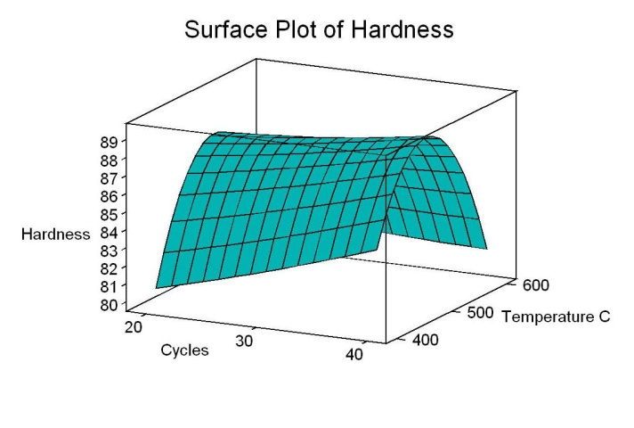
Fig. 5: The 3D-surface plot of the hardness (HRB) as a response and cycling temperature and No. of cycles.

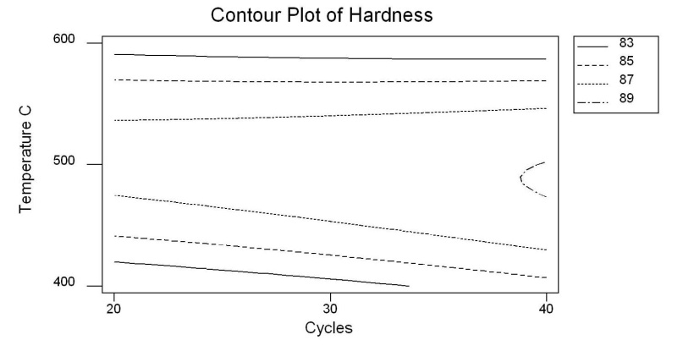
Fig. 6: The contour plot of the hardness (HRB) as a response and cycling temperature and No. of cycles.

This residual stresses are generated from the rapid cooling of the thermal cycling processes. However, for the 600 ºC temperature results this residual stresses would be relieved each time the specimens are reheated for the subsequent cycle.
Corrosion Rate Analysis: The corrosion rate results were analyzed and the interactions of thermal cycling parameters were identified. The statistical analysis for full quadratic model for corrosion rate measurements gives coefficients of determination of R² and R²-Adj equal to 88.9 % and 70% respectively, which shows that the performed corrosion rate regression is reasonably good. Therefore, the verified model for corrosion rate is as follows:

CR (g) = 8.01 - 0.08799 C -0.02706 T + 0.00075 C²
+ 0.00003 T² + 0.00009 CT (2)

Where, CR is the corrosion rate expressed as the weight loss in grams, C is number of cycles, T is cycling temperature (ºC).

Corrosion rate parametric study: The effects of thermal cycling processing parameters on corrosion rate for low carbon steel are presented in Figs.7 and 8 as 3D surface plot and contour plot obtained using the MINITAB developed model of Eq. (2). As shown in the 3D- surface plot of Fig. 7, the effect of the cycling temperature is more significant than the number of cycles. However, based on the results obtained, regarding the number of cycles, the decrease of corrosion rate with increasing the number of cycles is almost linear within the selected range. The effect of the cycling temperature is decreasing with the corrosion rate in a non-linear curve until a minimum at about 500 ºC, and then it is increasing again. These findings are confirmed by the contour plot of Fig. 8, which shows the effect of the number of cycles as approximately horizontal lines. The effect of the cycling temperature is very clear with a region of minimum corrosion rate around the 500 ºC temperature. Before this 500 ºC temperature, corrosion was high and decreases due to residual stresses building up (more stored energy). However, for the 600 ºC temperature results even though this residual stresses would be relieved each time the specimens are reheated for the subsequent cycle, the corrosion rate increases again due to oxidation which is reported to start at about 570 ºC [12].
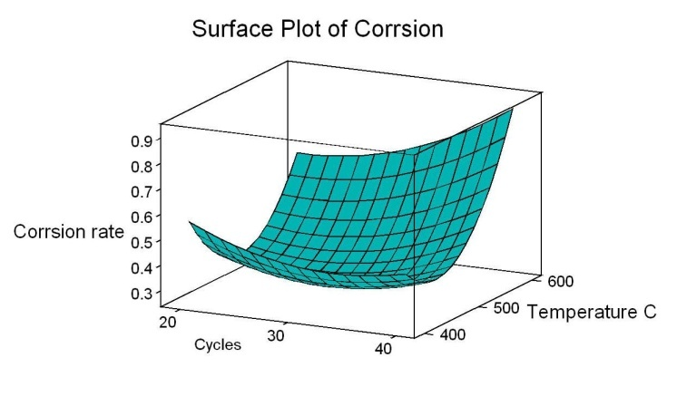
Fig. 7: The 3D-surface plot of the corrosion rate as a response and cycling temperature and No. of cycles.

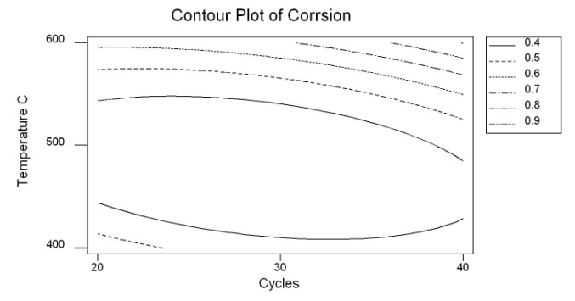
Fig. 8: The contour plot of the corrosion rate as a response and cycling temperature and No. of cycles

CONCLUSIONS
From this experimental study, the thermal cycling temperature was found to have more significant effects than the number of cycles on both the hardness and the corrosion rate. Increasing the thermal cycling temperature was found to increase the hardness and decrease the corrosion rate until 500ºC where peak is obtained, and then it is followed by a decrease in the hardness and decrease in corrosion rate as cycling temperature reaches 600 ºC . Empirical models for the hardness, and the corrosion rate as function of the cycling temperature, and the number of cycles were developed using the RSM approach. The models were found to be reasonably describing these effects.

REFERENCES
[1].www.sail.com accessed at May 2010.
[2].www.Iron and Steel Industry .com, The Canadian Encyclopedia.htm. Accessed at Jan 2010.

[3]. Bello K.A., Hassan S.B. and Abdulwahab M., " Effects of Tempering on the Microstructure and Mechanical Properties of Low Carbon, Low Alloy Martensitic Steel", Department of Metallurgical Engineering, Ahmadu Bello University Zaria, Nigeria, Journal of Applied Sciences Research - 2007, page 2.

[4]. D.I. Adebiyi, B.O. Adewuyi and A.A. Afonja., "Effect of Carbon Content on the Grain Refinement of Locally Produced Plain Carbon Steel by Thermal Cycling", Journal of Applied Sciences Research, 2009, INSInet Publication, page 7

[5]. Sanjib kumar jaypuria.," A Project Report on Heat Treatment of Low Carbon Steel", Department of Mechanical Engineering, National Institute of Technology, page 8, Session 2008-09.

[6]. The ASM Committee on, "Alloy phase diagram ", ASM Metals Handbook, page 232 , vol 3, 2005.
[7]. M. H. Jokhio, S. A. Memon, and M. J. Sangi, "Effect of heat treatment on the microstructure and mechanical properties of low carbon ASE1010 steel", E-Awam University research journal of engineering science & technology, vol 1, no 1, page 6., 2000.

[8]. T. Foley and A. Levy., "The erosion of heat-treated steels", Wear, Volume 91, Issue 1, Pages 45-64, 1983.

[9]. William E. Smith, Javad. Hashemi, "Foundations of Materials Science and Engineering", 3rd edition, McGraw-Hill, ch 7, Inc 1993.
[10]. William D. Callister, Jr., " Fundamentals of Materials Science and Engineering", 2nd edition, John Wiley& Sons, ch 13,page 533. Inc 2005.
[11]. Sidney H. Avner, "Introduction to physical metallurgy", 2nd edition.ch8,p 282-284.

[12]. V. B. TrindadeI, R. Borin, B.Z. HanjariI, S. Yang, U. Krupp, H.J.Christ, " High-temperature oxidation of pure Fe and the ferritic steel 2.25Cr1Mo", Institut für Werkstofftechnik, Universität Siegen, Germany,
Materials Research, vol 4, pages 9-10, 2005.

